Narcotics – Fentanyl Response

From TPD Wiki
Counter Narcotics Alliance
CALL CNA FOR ANY INCIDENTS THAT INVOLVE BOTH A NEXUS TO DRUGS AND INTEL INDICATING FENTANYL PRESENCE:
INDICATION OF DRUG NEXUS:
- Presence of drugs
- Paraphernalia
- Informant or source info (example: roommate or relative reports subject possesses or sells narcotics)
- Packaging
- Cutting materials (non-drug material used to inflate drug volume such as; adding Mannitol to cocaine)

INDICATION OF FENTANYL
- Informant or source info (example: roommate, relative, or informant reports subject possesses or sells Fentanyl)
- Visual evidence of mixing or blending white powder with heroin
- Pill press or tableting equipment
- Packaging from shipments (especially originating from china or port locations such as California)
- Packaging from compartment or trafficking (see images below)
- Large amounts of similar pills
- Handwritten notes or messages, phone text messages, or labeling with Fentanyl wording
- Suspicious death / overdose and check welfare calls
SEE CNA CALL OUT LIST FOR CALL OUTS OR RELATED FENTANYL QUESTIONS

Contents
- 1 FENTANYL CAUTIONS
- 2 EVACUATION/SCENE SECURITY
- 3 PACKAGING EXAMPLES
- 4 PILLS
- 5 TABLETING AND PILL MANUFACTURING

FENTANYL CAUTIONS

Fentanyl is absorbed readily through skin, mucous membranes (eyes, mouth, nose), and open wounds. Moisture such as sweat increases danger of skin absorption.

Agitation of powdered Fentanyl can cause the powder to be airborne and create an inhalation hazard. Airborne Fentanyl can contaminate clothing and hair and delay exposure.

Fentanyl used in manufacturing pills and cutting with other drugs may be unevenly distributed. Handling pills and packaging without protective gear may create dangerous exposure levels

UNKNOWN DRUG SUBSTANCES SHOULD NOT BE FIELD/NARCOPOUCH TESTED

FENTANYL EVACUATIONS
- Fentanyl evacuations are required in any area where the suspected substance can become airborne, or is subject to changing environment conditions.
- If an evacuation is conducted:
  - Ensure that the evacuation area is sealed as best as possible. In a room, close all doors and windows from the exterior.
  - Disable any air flow sources such as; air conditioning, fans, exposure to wind.
  - Ensure that all areas with shared air space, ducting, common doors, etc. are also evacuated
  - If possible turn off power to suspect contamination area.
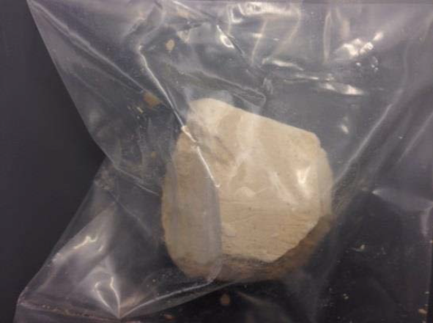
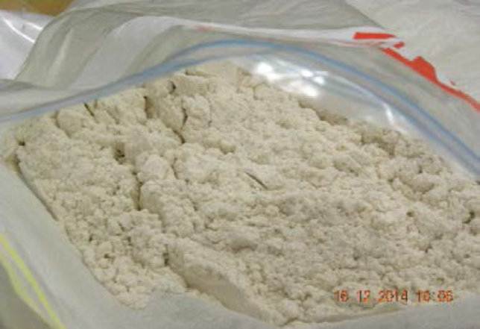
FENTANYL EXAMPLES

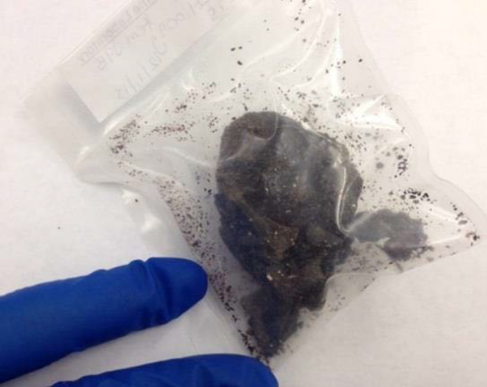
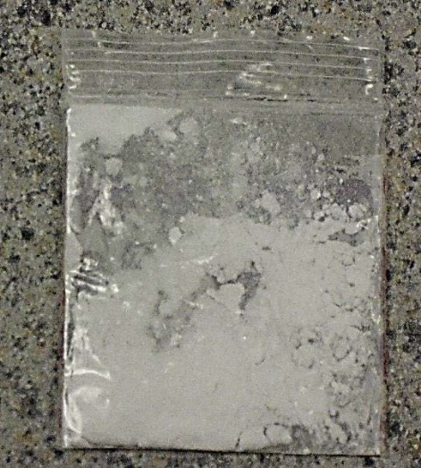

HEROIN LACED WITH FENTANYL.
TPD case: Check welfare in an apartment. Deceased male made statements about routinely receiving Fentanyl from China. A box with shipping label from Shanghai, China was found in the residence.
PACKAGING EXAMPLES
Packaging from Vehicle Compartments:
YAVAPAI COUNTY SHERIFF’S
Seizure: 5 Packages containing 14 pounds of Fentanyl powder
Concealment: concealed in a spare tire. The drugs were also placed in Tupperware containers coated with axle grease, then wrapped in plastic and coated with a second layer of axle grease and secured inside two food saver bags. The packages were additionally wrapped in aluminum foil THEN placed in the food saver bags.
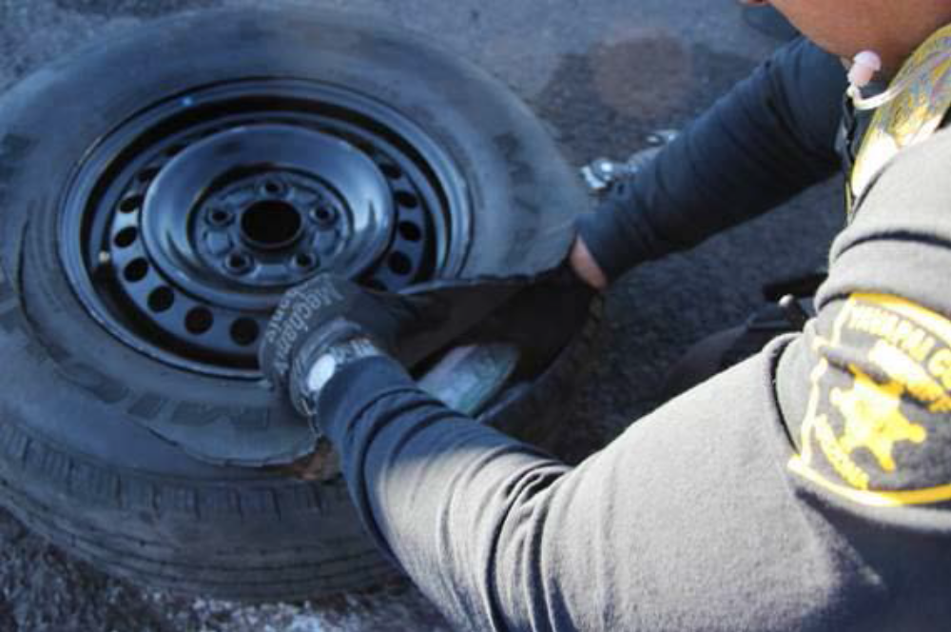

Photographs: Arizona
Agency: Arizona Department of Public Safety
Incident: Traffic stop on a 2000 Ford F-150 pickup registered in Arizona
Origin and Destination: Origin: Agua Prieta, Mexico and destination: Queen Creek, Arizona
Seizure: 15 packages containing 16 pounds of Fentanyl powder
Concealment: The packages were wrapped in yellow electrical tape and concealed within the front and rear drive shafts.

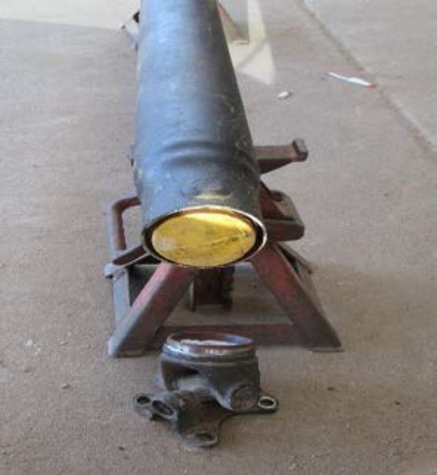
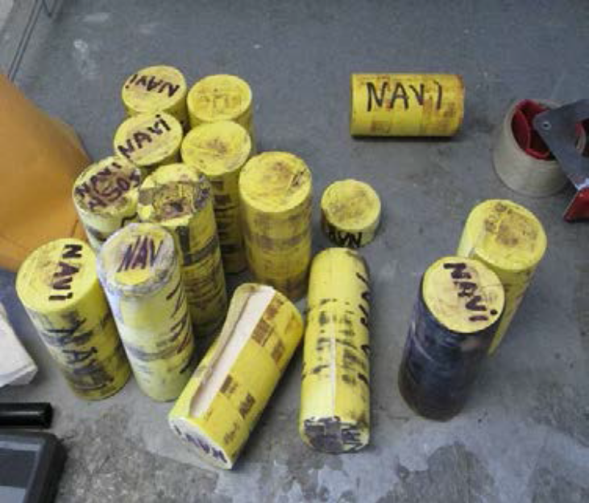

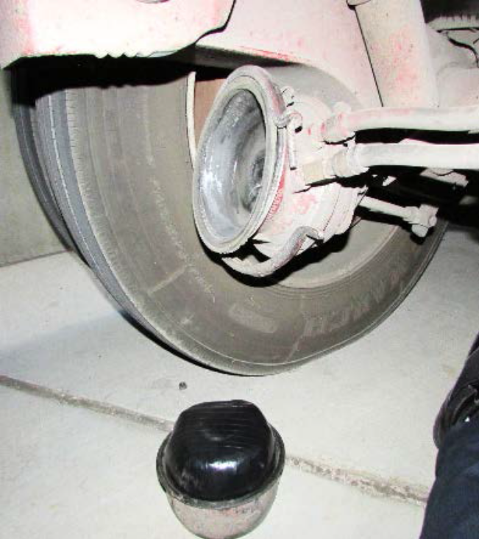
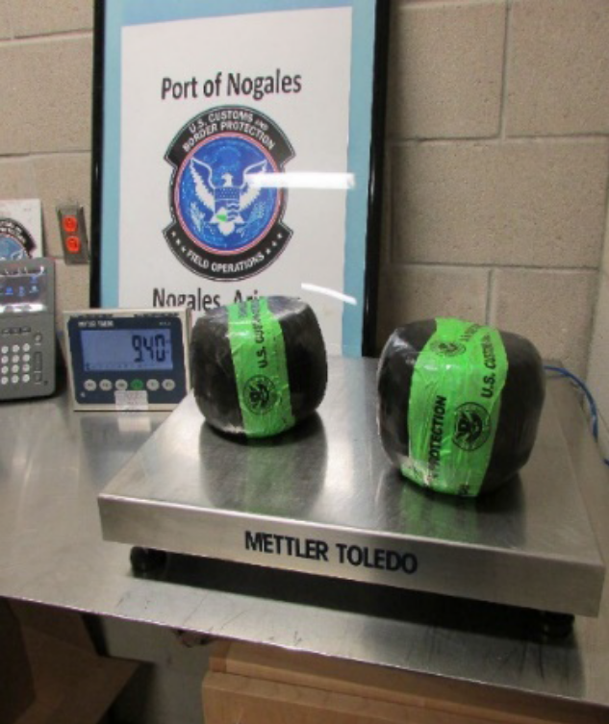
TWO PACKAGES WITH A TOTAL OF 8.5 KILOS OF FENTANYL CONCEALED IN SEMI BRAKE SPRING CYLINDERS

PILLS
Many of the recent seizures involving Fentanyl are related to manufactured pills mimicking legitimate pharmaceutical tablets. Pills have been interdicted which appear to have been produced in Mexico and trafficked through Arizona.
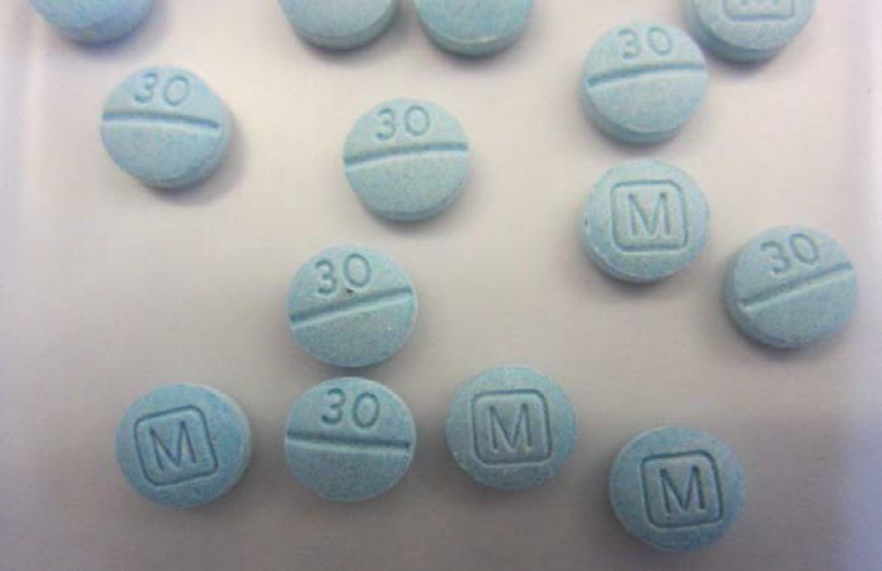

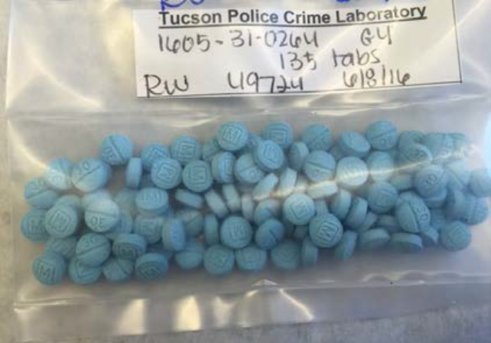
CNA CASE: PILLS CONTAINED FENTANYL, CAFFEINE, TRAMADOL
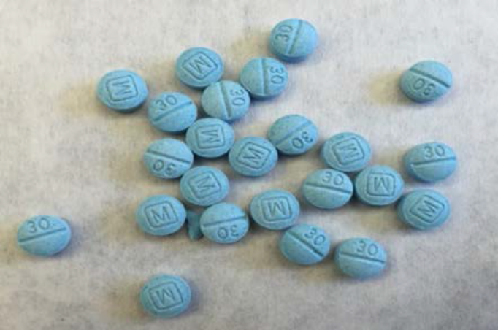

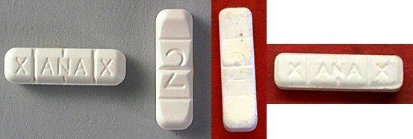
TPD PATROL: CHECK WELFARE CALL. PILLS CONTAINED FENTANYL, CAFFEINE, AND ACETAMINOPHEN

LEFT: REAL PILL, RIGHT: COUNTERFEIT PILL

TABLETING AND PILL MANUFACTURE
Intel indicates that some drug organizations are manufacturing pills with Fentanyl in the U.S.
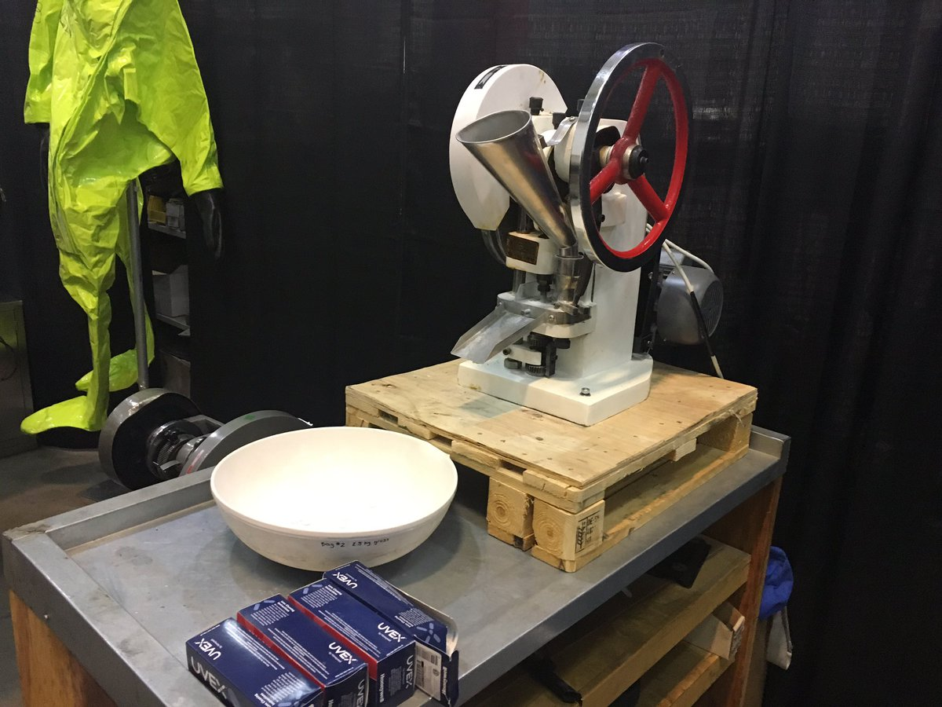

PILL PRESS
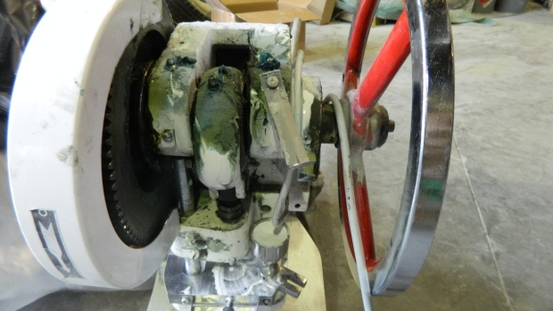

PILL PRESS FROM CANADIAN CASE. MACHINE IS COVERED WITH FENTANYL RESIDUE.
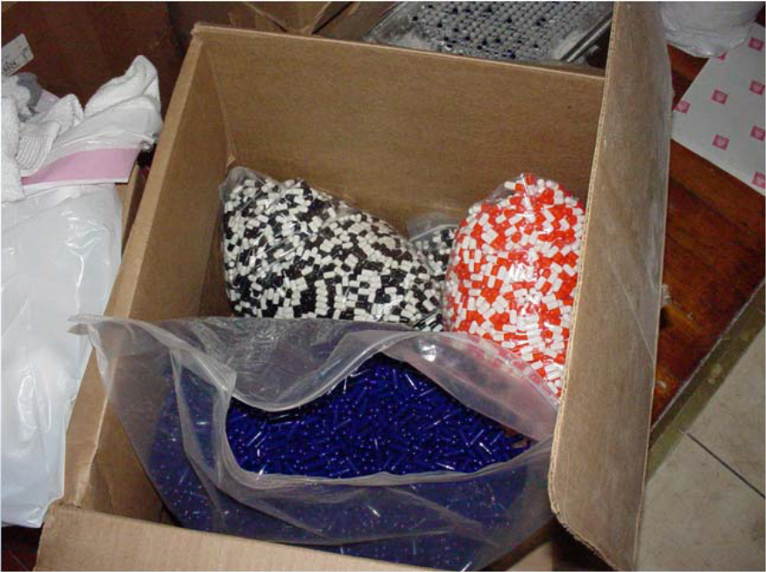

BULK CAPSULE SUPPLIES

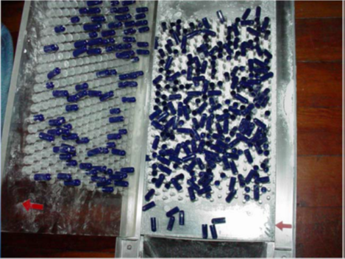

MANUAL CAPSULE CASING/FILLING EQUIPMENT

FENTANYL CUTTING LAB – FENTANYL IS CUT AND REDUCED

EXTREME RISK OF EXPOSURE AND AIRBORNE CONTAMINATION!!!

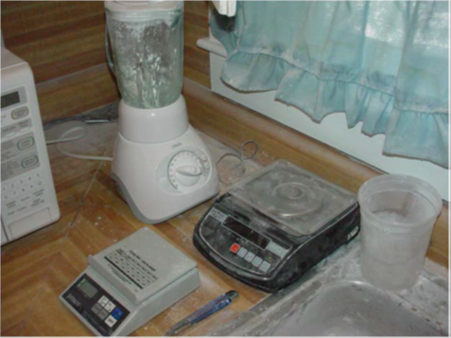
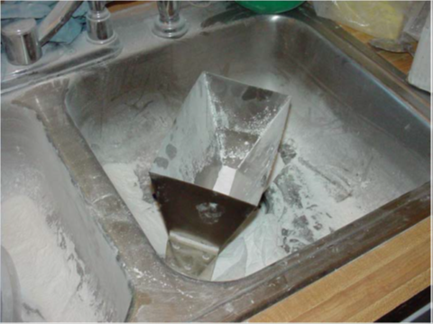
LEVEL A HAZMAT RESPONSE ONLY

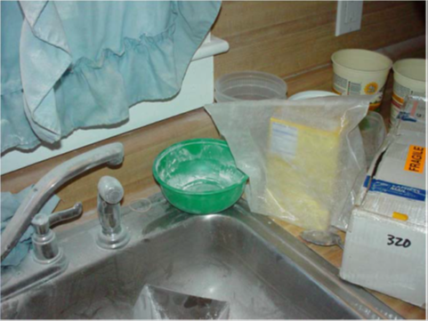
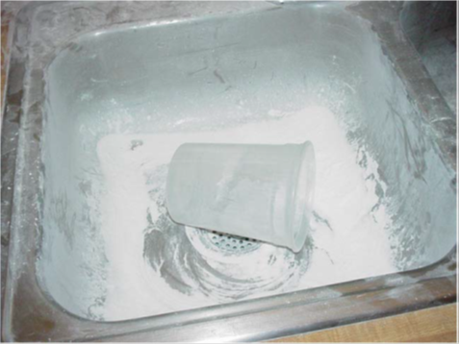

FENTANYL LAB CHEMICALS EXAMPLES

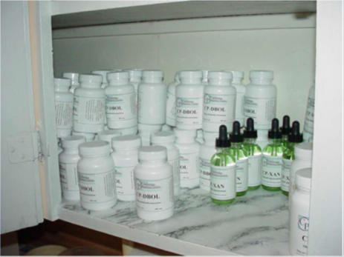
Precursors:
– NPP
– 4-piperidone
– Phenethyl-bromide

Precursors:
– Phenethyl-tosylate
– phenylacetaldehyde
– ANPP
– Sodium
Triacetoxyborohydride
• Reagents
– Aniline
– Propionyl chloride
– Sodium borohydride•

EXAMPLES OF COMMERCIAL CHEMICAL SUPPLIERS



RESULT OF A FAILED ATTEMPT TO DESTROY FENTANYL WHEN LAW ENFORCEMENT ARRIVES……..


